Dis-Asia-Indus-Idol Figures

Ancient teracotta idol figure indus valley circa 2000-1500 BC.  
Combine shipment for multiple purchases.  
Shipping/handling $20 worldwide.  
10 cm  Height   
7 cm Diameter  
Ex Euroepean collection

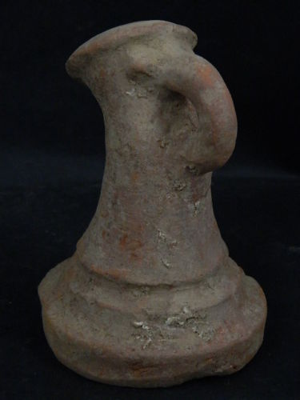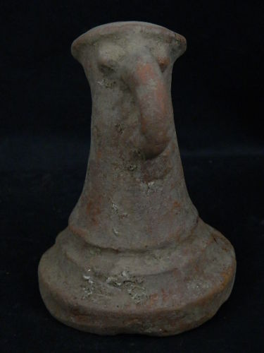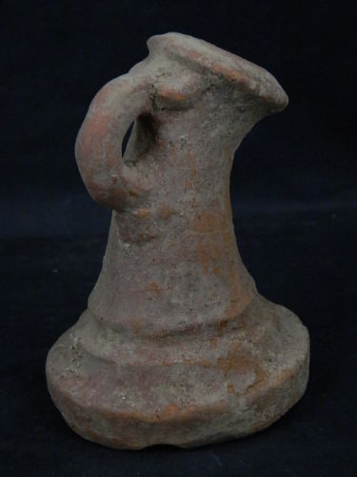 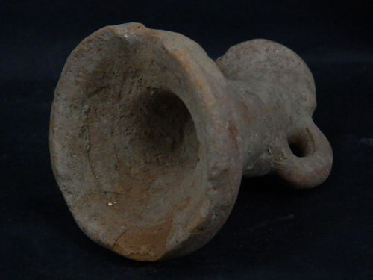

Terracotta idol figure indus valley circa 900-800 BC.  
5 cm  Height   
3.5 cm Length  
Ex European collection  
 